Research Notes - Mate ROV
Date: 06/22/2025
Researcher(s):
Khalid Abou-Khamis
Objective of research:
Safety Documentation Needed
Notes:

REQUIRED SAFETY VIDEO (Design & Build Inspection)
Must create and submit a video that clearly shows the following (in this order):
- 48V power supply (≥15 seconds)
- Fuse near Powerpole connector with a ruler measuring ≤30 cm (≥15 seconds)
- Inside control box (≥30 seconds) showing:
  - No exposed wiring
  - Neat layout
  - Clear separation of AC/DC (or statement slide if no AC power)
- No surface-side voltage conversion: power conversion must happen only on the ROV (≥15 seconds)
- Hydraulic/pneumatic system (≥30 seconds) showing:
  - On/off valve, regulator, pressure release
  - Pressure ratings of tubing
  - Type of fluid used (or 10s slide if no fluid system used)
- Topside strain relief (≥15 seconds)
- ROV-side strain relief (≥15 seconds)
- 360° motor and edge inspection: each side + top and bottom (≥10 seconds each side, ≥60 seconds total)

REQUIRED SAFETY DOCUMENTATION
You must submit:
- System Interconnection Diagram (SID): shows fuse location, voltages, wire routing, current draws, etc.
- Safety Review Documentation:
  - Photos of all safety-critical features
  - Fuse sizing calculation
  - Statement of whether fluid power is used
- Jobsite Safety and Environmental Analysis (JSEA):
  - Hazards identified during setup, operation, teardown
  - Mitigation measures listed for each hazard
  - Responsible team member for each step
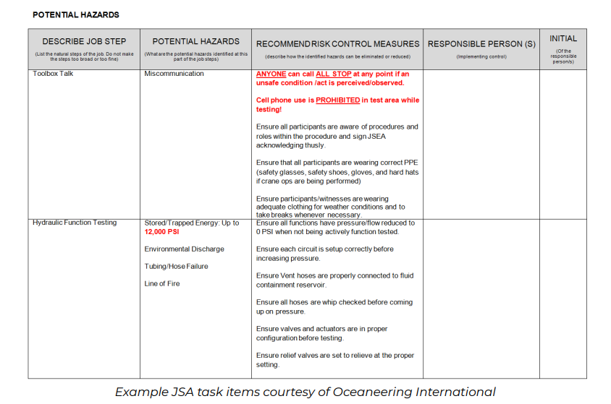

Example of JSEA:
Task / Step | Potential Hazard | Consequence | Preventive Action (Control Measures) | Person Responsible
Connect 48V Power Supply | Electrical shock | Personal injury | Power off during connection; use insulated tools/gloves | B
Install Fuse Near Powerpole | Incorrect fuse sizing | System damage, fire risk | Verify fuse rating with SID; measure placement (<30 cm) | K
Route Wires Inside Control Box | Loose or crossed wiring | Short circuit, failed inspection | Neatly bundle and label wires; separate AC/DC if applicable | T
Tether Enters Control Box | Cable strain or fraying | Disconnection, exposed wires | Use rubber grommets and secure strain relief | T
Launch ROV by Hand | Dropping ROV | Injuries, damage to vehicle | Two-person lift, communicate clearly, lift from frame, not wires | K
Activate Brushless Thrusters | Propeller contact | Finger injury, cuts | Verify all props are shrouded; never touch in water when powered | B
Pilot ROV in Pool | Tether snag or entanglement | Loss of control or damage | Maintain slack; assign one person to manage tether at all times | T
Use Pneumatic Claw Tool | Overpressure or tubing failure | Loud release, minor injury | Regulate to safe PSI, verify rated tubing, check for leaks | B
Sample Water or Use Sensor Tool | Contact with contaminated water | Irritation or unknown exposure | Wear gloves; sanitize sampling tools after use | K
Recover ROV from Water | Water dripping onto electronics | Short circuit | Towel off and disconnect power before recovery | T
Disconnect Battery Post-Demo | Arc or backfeed | Shock or spark | Switch off breaker, unplug safely, follow LOTO (lockout/tagout) | B
Coil and Store Tether | Trip hazard | Falls or equipment damage | Coil neatly, use velcro straps or cable reel | K
Transport Battery | Drop, thermal short, or puncture | Fire hazard | Use a hard-shell battery case, isolate terminals | T
Move Equipment to/from Deck Area | Tripping or lifting injury | Back strain, dropped equipment | Clear paths, bend at knees, carry in pairs if heavy | K
Perform Final Inspection | Missed sharp edges or loose wires | Safety violation | Use checklist; dry system fully; confirm no exposed conductors | B

SAFETY INSPECTION (At Competition)
MATE judges will inspect the vehicle based on:
- Match with safety video and documentation
- Live checks for fuse, wire insulation, strain reliefs, sharp edges
- Safety compliance for any pneumatic or hydraulic systems
Penalties & Disqualification:
- 10-point deduction per failed attempt
- 3 failed inspections = disqualification from in-water demo

Sources:
2025 MATE Competition Manual Page Covers
https://20693798.fs1.hubspotusercontent-na1.net/hubfs/20693798/2025%20EXPLORER%20Manual_FINAL_1_6_withCover.pdf
ChatGPT used to generate JSEA table as a quick example

